**Institute of Engineering & Management**

**Department of Computer Science & Engineering**

**Network Lab for 3rd year 6th semester 2019**

**Code: CS 692**

**Date:** 01/04/19

**WEEK-5**

**Assignment-1**

**Problem Statement:** Standard Number Access Control List

**Screen-Shot:**

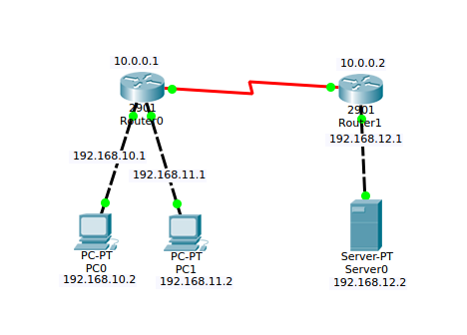

**CLI code:**

**Router-1:**

Router>en

Router#configure terminal

Router(config)#interface gigabitEthernet 0/0

Router(config-if)#ip address 192.168.10.1 255.255.255.0

Router(config-if)#no shutdown

Router(config-if)#exit

Router(config)#interface gigabitEthernet 0/1

Router(config-if)#ip address 192.168.11.1 255.255.255.0

Router(config-if)#no shutdown

Router(config-if)#exit

Router(config)#interface serial 0/3/0

Router(config-if)#ip address 10.0.0.1 255.0.0.0

Router(config-if)#clock rate 64000

Router(config-if)#no shutdown

Router(config)#router rip

Router(config-router)#network 192.168.10.0

Router(config-router)#network 192.168.11.0

Router(config-router)#network 10.0.0.0

Router(config-router)#version 2

Router(config-router)#exit

Router(config)#access-list 2 deny 192.168.11.0 0.0.0.255

Router(config)#access-list 2 permit any

Router(config)#interface serial 0/3/0

Router(config-if)#ip access-group 2 out

**Router-2:**

Router>en

Router#configure terminal

Router(config)#interface gigabitEthernet 0/0

Router(config-if)#ip address 192.168.12.1 255.255.255.0

Router(config-if)#no shutdown

Router(config-if)#exit

Router(config)#interface serial 0/3/0

Router(config-if)#ip address 10.0.0.2 255.0.0.0

Router(config-if)#no shutdown

Router(config-if)#exit

Router(config)#router rip

Router(config-router)#network 192.168.12.0

Router(config-router)#network 10.0.0.0

Router(config-router)#version 2

Router(config-router)#exit